DOCUMENT REQUIREMENT SPECIFICATION (SRS) Document BookStore Online Website 09/26/2024 Version 1

Thanh Van Thai, Carson Barnard

1. ProjectGeneralDescription  
   This project will be developing a bookstore for users to order a selection of books from, and for admins to be able to track orders. Allows customers to have their books delivered to them with ease! Once you create an account for our online bookstore, you will have the ability to browse categories and best-sellers, or search up their preferred books individually. They are able to see all the information about that book (author, description, identifiers), and read other users reviews about said book, as well as see every order they have ever placed. Admins will be able to manage categories and reviews, delete any inappropriate ones (could also set up a profanity filter). Admins also have the ability of tracking an order's status, seeing how far into the process it has came and view selling statistics. Additionally, admin can create and manage providers.
2. ProductFeatures  
   Customer can browse the online book store by category (e.g. Health, Success, Business, Programming, etc) or they can search books by providing a specific keyword e.g. ‘success habits’. The customer can view basic information about a book like title, author, description, ISBN number, publish date and price. In addition, they can read reviews of other customers as well as average rating of a book, which can be ranged from 0 to 5 stars.  
   The website lists all categories in the top menu, which allows the customer to browse books in a specific domain. On the home page, the customer can see the most recently published books (based on the publish date, not by the date on which the book is put onto the website). Then they can see the best-selling books (based on the number of orders have been made through the website), and the most favored books (based on their rating and number of reviews).  
   When reading the details of a book, the customer can add the book to his shopping cart by hitting the button ‘Add to Cart’. Then they can see their shopping cart listing all the books that have been added. Note that adding a book multiple times to the shopping cart will increase the quantity (number of copies). The shopping cart page allows the customer to edit the quantity, remove books and even empty the cart.  
   The information in shopping cart is maintained during the customer’s session, which means that she can continue navigating the site before placing an order. The website also provides a menu that allows the customer to see her shopping cart quickly and for convenience, they do not have to login first to use the shopping cart.  
   The website also allows the customer to view their registered information (profile details) and edit it. Note that the customer cannot change their

registered email address, and their password won’t be changed if left blank in the edit form.

Also note that when the customer logs out, the information in their shopping cart is cleared.

At any time, the customer can search the books they want by typing a keyword in the search box at the top of the site. The search result shows books that have either title or description contain the specified keyword. The customer can add the book to cart directly in the search result.

3. FunctionalRequirements

-FR0: The website will allow all users to create a profile.  
- FR1: The website will allow all users to modify their profile.  
- FR2: The website will allow the user to search books based on category or keyword.  
- FR3: The website will allow the user to review books.  
- FR4: The website will allow the user to view the most-recently published, the best-selling , and the most favored books.  
- FR5: The website will allow user to add, remove, change quantity of books to their shopping cart.  
- FR6: The website will allow user to check out.  
- FR7: The website will allow administrators to create, update, and delete books  
- FR8: The website will allow administrators to create, update, and delete providers  
- FR9: The website will allow administrators to delete any inappropriate reviews  
- FR10: The website will allow administrators to view selling statistics  
- FR11: The website will allow administrators to update shipping information and status of an order  
- FR 12: Accounts will be protected by login pages with passwords.

4. Non-Functional Requirements

- NRR0: The website should load pages within 3 seconds under normal load conditions.

- NRR1: The design should be intuitive and easy to navigate.

- NRR2: All user data, including personal and payment information, should be encrypted using industry-standard protocols

- NRR3: The codebase should follow best practices and be well-documented to facilitate easy maintenance and updates.

- NRR4: The database should be able to scale to handle large volumes of transactions and data.

5. Scenarios  
a. Users(Customers)-Carson Barnard

**Customer Use Case: Create/Modify User Profile**

**Initial Assumption:**

A new user will be able to create a profile with private information such as their name, their address, their email address, their phone number, and their age.

An existing user will have the ability to modify their user profile and change any part of the information they provided upon their initial creation of said user profile.

The user profile can be created by any time by clicking the register option on the beginning log-in page. Once logged in this profile can access all parts of the user site, and if edits need to be made to the profile then the user can click an edit profile button in their profile section where they can make the necessary changes and save their profile with the new information.

**Normal:**

A new user will be prompted at checkout to create a new user profile or checkout as a guest. If they choose to create a profile they will be redirected to a separate page and will be asked to enter the information we need to create a new profile. A new user can also create a new profile by clicking/hovering on the profile icon in the navigation menu at the top of the screen. This will give the user the option to sign in/sign up, and from there they are able to create their new profile.

An existing user can access the sign in page from hovering/clicking on the profile icon in the navigation menu. Once signed in they are able to click on the profile icon again and view their information as well as modify their information and save the new input to their profile.

**What Could go Wrong:**

The user profile creation page could not immediately redirect a new user to their page visited prior to creating the profile. It could also not redirect an existing user to the user profile page with their new information added to it after modification.

It could not save new information added to the user profile from a new/existing user.

**Other Activities:** User profile can be viewed but not edited by system administrators. It cannot be viewed by anyone else but the user themselves.

**System State on Completion:**

On completion a user profile will be created/modified and the user’s information will be saved to our system. The user will be redirected to their necessary page upon completion.

**Customer Use Case: View Available Services**

**Initial Assumption:**

A customer is able to view the online shop, view reviews on individual books they select, and add books to their shopping cart for checkout. A customer can also search for a book.

**Normal:**

A customer can see a list of categories to shop from including a shop all, newly published, best-selling, and best reviewed options.

When a customer clicks on a book they can see the basic information, the reviews, as well as an add to cart option.

If a customer searches for a book a page will pop up with every option that fits their query.

**What Could go Wrong:**

When searching for certain keywords there could be complications with the results provided.

The sorting of results based on the category selected by the user could have complications if not sorted correctly.

The add to cart button might not actually add the book to cart or could have complications popping up a small snapshot of the users live cart when the book is added.

**Other Activities:**

Users can add a book to their wish list and this information will be saved to their profile so they can keep track of books they are interested in purchasing.

**System State on Completion:** On completion the user will be able to add a book to their cart after they have used our product pages to shop and find what books they want to purchase.

**Customer Use Case: Subscribe to Available Services Initial Assumption:**

A customer will be able to subscribe to our monthly staff pick service. This service will send a monthly staff picked book to users that enroll at a discounted price. This option will be accessible when hovering over the shop option on the navigation menu.

**Normal:**

Upon customer enrollment to this service, they will be redirected to a page that says, “Subscription Successful!” as well as a notification that the first monthly books order has been processed.

If a user wants to end their subscription, they need to go to their user profile and select the button that says, “Cancel Monthly Staff Pick Subscription.” A banner will show up notifying the customer that the subscription has ended.

**What Could go Wrong:**

If the user is not redirected to the page that says the subscription has been successful as well as the information about this month’s staff pick then this will be a problem.

If a user selects that they want to end their subscription, and the banner notification does not show up this will be a complication. We also need to make sure they are taken off of the subscription list.

**Other Activities:**

The system admin will be able to remove users from the subscription service if their payment for that month has not been processed in X amount of time.

**System State on Completion:**

A user will be on the page they are redirected to for the subscription completion confirmation and they will be able to navigate the website just like they were previous to signing up for the subscription.

**Initial Assumption:**

**Customer Use Case: Write Review**

Upon purchase a customer will be able to write a review for the book. If the customer did not purchase a book, they will not be able to write a review for it.

**Normal:**

When a customer purchases a book, they will be notified that they can return to that book's personal page at any time to write a review and rate the book.

The customer will be told that they must be logged in to their account to write the review, as guests will never have this permission even for purchased books.

The review will be saved to the website and the customer will be thanked for their honest opinion.

**What Could go Wrong:**

If the permissions to review a certain book are not granted upon purchase of said book, this will be a problem.

If the notifications that they are able to review that book and they must be logged in to do so are not shown to the user, then this will be a problem. Also, we need to ensure that the user is thanked for their honest review when they submit it.

We must make sure that the review is saved for all users to see when the user has submitted it and the browser is refreshed.

**Other Activities:**

The system admin will have the ability to remove reviews using bad language or hate speech.

**System State on Completion:** After a user has written a review they will be thanked for their review through a quick banner notification and redirected to the books page.

b. Providers - Carson Barnard

**1. Create/Modify/Withdraw Provider Profile Scenario:**

*Provider wants to create a profile for the online bookstore.*

* ● **Actor:** Provider
* ● **Precondition:** Provider is authenticated.
* ● **Main Flow:**
  1. Providernavigatestothe"CreateProfile"section.
  2. Providerfillsoutthebookpublisher’sname,address,phonenumber,  
     email, and description (If necessary).
  3. Providersubmitstheprofileform.
  4. Thesystemconfirmsprofilecreationwithasuccessmessage.
* **Alternative Flow:**

● If the provider wants to update their profile, they navigate to "Edit Profile," make changes, and submit again.

**2. Create Services Scenario:**

*Provider wants to add a new book to the listings available.*

* ● **Actor:** Provider
* ● **Precondition:** Provider has an active profile.
* ● **Main Flow:**
  1. Providernavigatestothe"AddBook”section.
  2. Providerinputsbookdetails,includingtitle,description,author,genre,  
     and pricing.
  3. Providersubmitstheformrequestingconfirmation.
  4. Thesystemconfirmsthebookhasbeenaddedsuccessfully.
* **3. View Customer Statistics Scenario:***Provider wants to check statistics about their books' performance.*
* ● **Actor:** Provider
* ● **Precondition:** Provider has listed services and at least some customer  
  interactions.
* ● **Main Flow:**

1. Providerclicksonthe"ViewStatistics"tab.
2. Thesystemdisplaysgraphsandmetrics(e.g.,numberofvisits,  
   average ratings).
3. Providerreviewsthedataforinsightsonthebook'sperformance.

**4. Reply to Review Scenario:**

*Provider receives a review for a book and wants to respond.*

b. **Actor:**Provider  
c. **Precondition:** Provider has at least one review. d. **MainFlow:**

* Providernavigatestotheiruploadedbook.
* Providergoestothe“Reviews”section
* Provider selects the review and analyzes it.
* Providerclicks"Reply"andwritesaresponse.
* Thesystemconfirmstheresponseispostedalongsidethereview.

c. SysAdmin - Thanh Van Thai

i. Manage User Access (Users login)

* ● Initial Assumption: New users can register and log in  
  BookStoreOnline website
* ● Normal:

o Users can create accounts with usernames, unique emails and strong passwords.

o Enforce password complexity rules (length, special characters).

o Authentication mechanisms are implemented. ● What Can Go Wrong:

o Failed login attempts are tracked and limited. ● Other Activities:

o Password reset functionality is available.

o Handle password resets and account recovery. ● System State on Completion:

o User can see main page of BookStoreOnline website ii. Moderate services (Remove an unavailable book)

* ● Initial Assumption: a book in the BookStoreOnline catalog that is no longer published or available. It needs to be removed from the website to maintain accurate and up-to-date content.
* ● Normal:

o SysAdmin accesses the backend system.  
o SysAdmin identifies the book that needs to be removed. o SysAdmin updates the book’s status to “unpublished” or

“out of stock.” ● What Can Go Wrong:

o If the book was previously available for purchase, the SysAdmin needs to notify users who had it in their cart.

o SysAdmin sends an email notification to inform users about the book’s removal.

● System State on Completion:  
o The book should not appear in search results and be

recommended to users.  
iii. Moderate reviews (Remove a violated review):

* ● Initial Assumption: A review that violates the website’s policy. It needs to be removed from the website
* ● Normal:

o SysAdmin accesses the backend system.  
o SysAdmin identifies user-generated reviews.  
o SysAdmin reads the flagged review to determine if it

indeed violates the policy.  
o SysAdmin updates the review’s status to indicate that it

violates the policy. ● Other Activities:

o A polite message can explain why the review was removed.

● System State on Completion:  
o The review is removed, and other users cannot see it.

Design Document

BookStore

10/31/2024

Carson Barnard, Thanh Van Thai

1. Project Overview

The goal of our project is to create an online bookstore that can be accessed by the general public (if released online) that facilitates the purchasing of paperback copies over the internet. Admins are responsible for updating the site with new books, and contacting publishers to make that happen. Users are presented with the books on the mainpage and are provided the ability to search for whatever they want or choose from a selection of genres. Users then have the ability to purchase the book, putting it in a cart, and then confirming their order details. After purchasing the book, Users can then leave a review on it. Admins will be responsible for moderating these reviews, and any other content on the website.

1. Use-Case Model - Both Admin and User

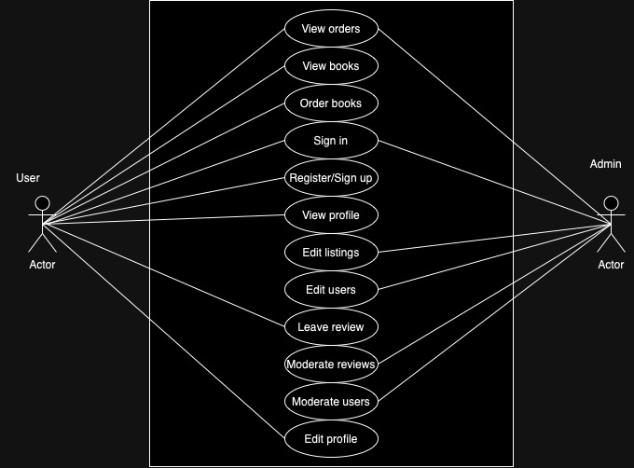

1. State Machine Diagrams

a- Customer (Carson Barnard)

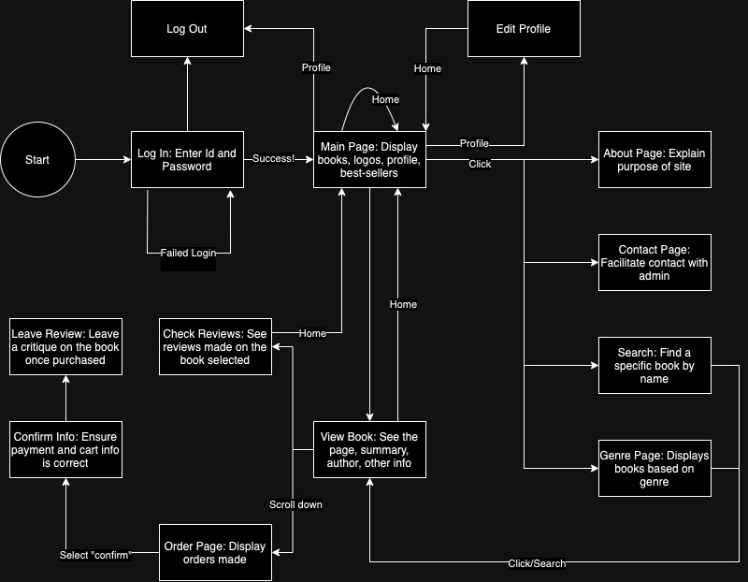

b- Admin (Thanh Van Thai)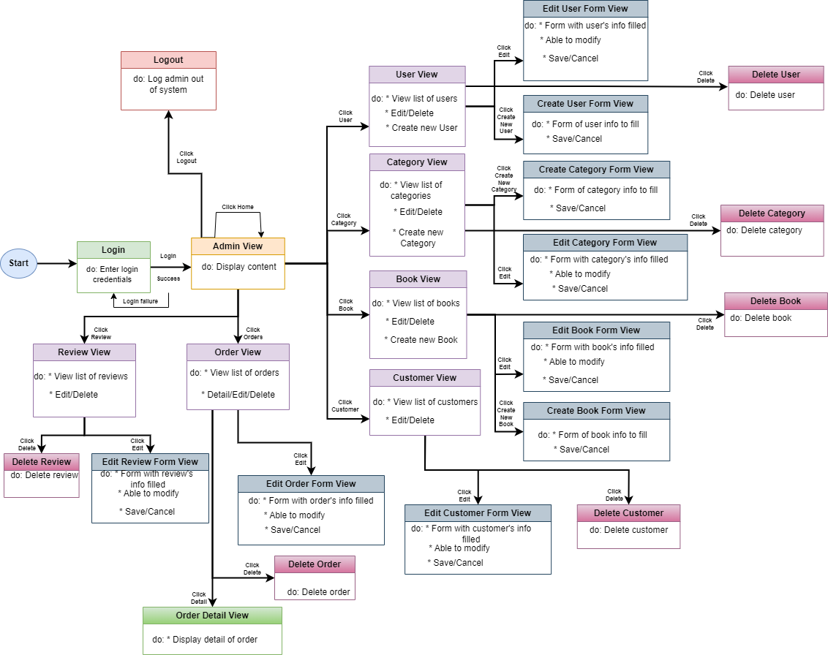

1. Database Schema - Both Admin and User

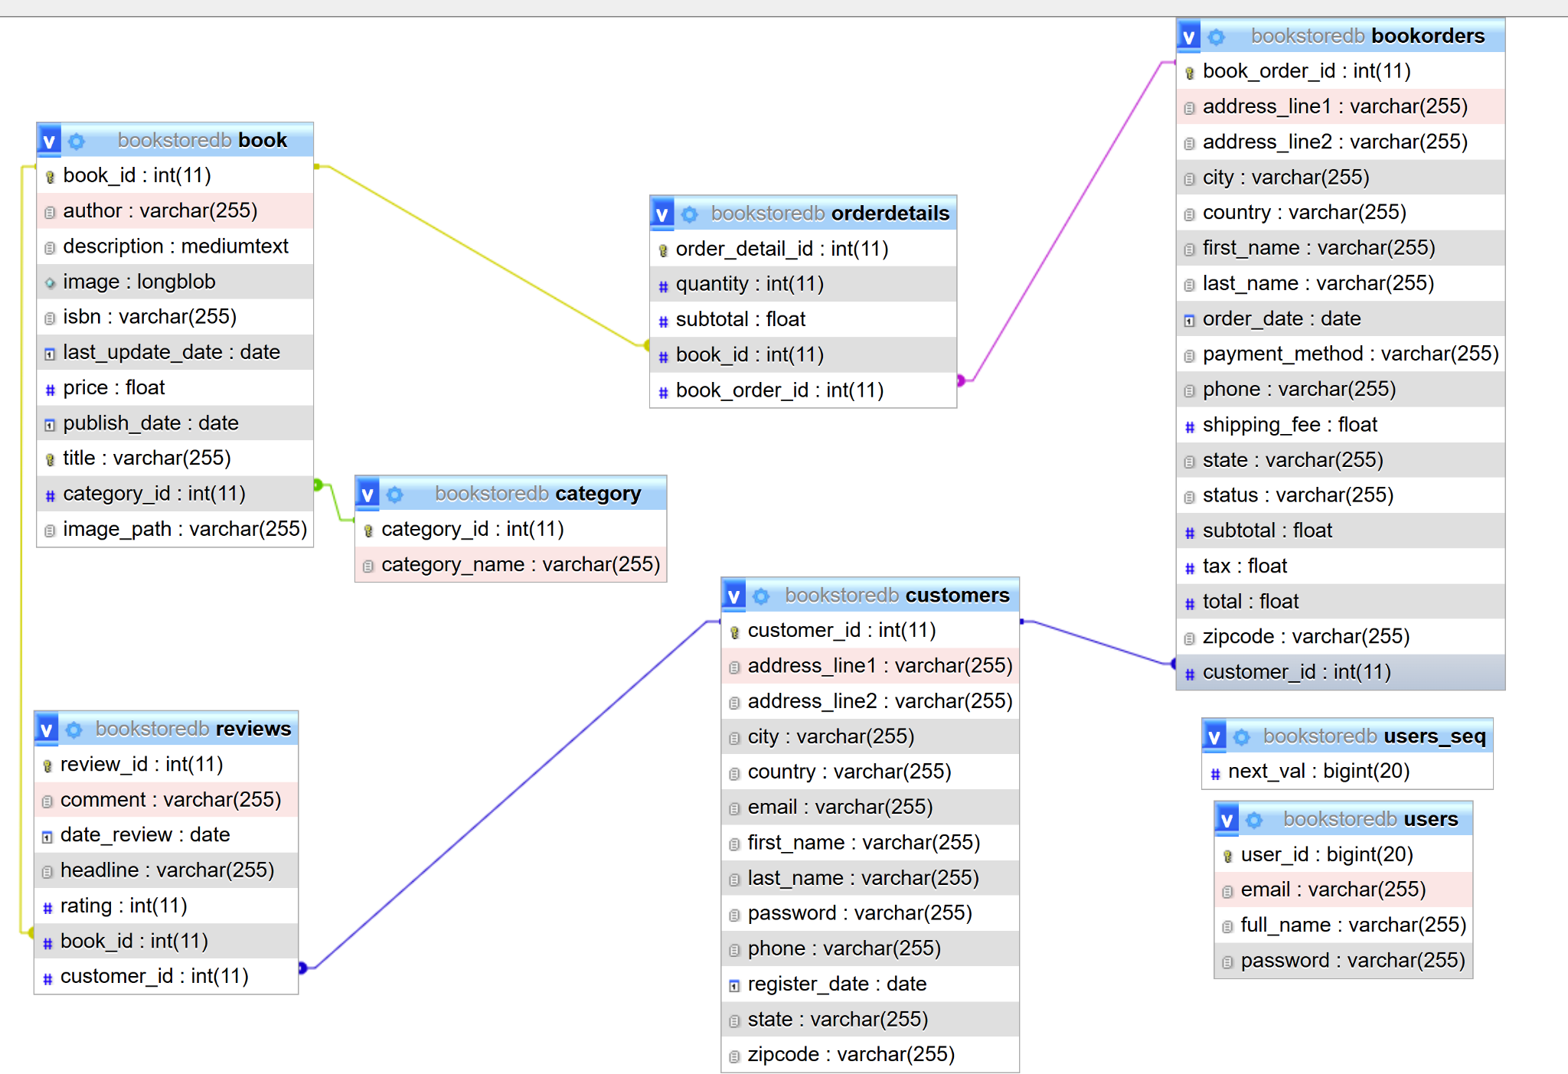

1. Software Architecture - MVC - Both Admin and User

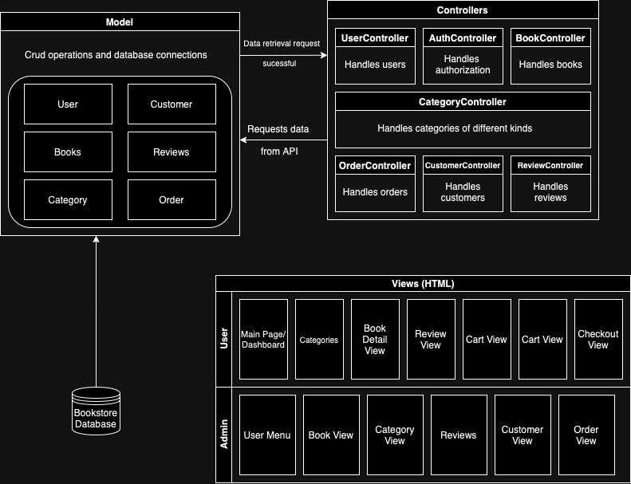

Scenarios With Screenshots

Customer 1: Register for profile and log in use case:

1: Customer accesses the website and is routed to the login page.

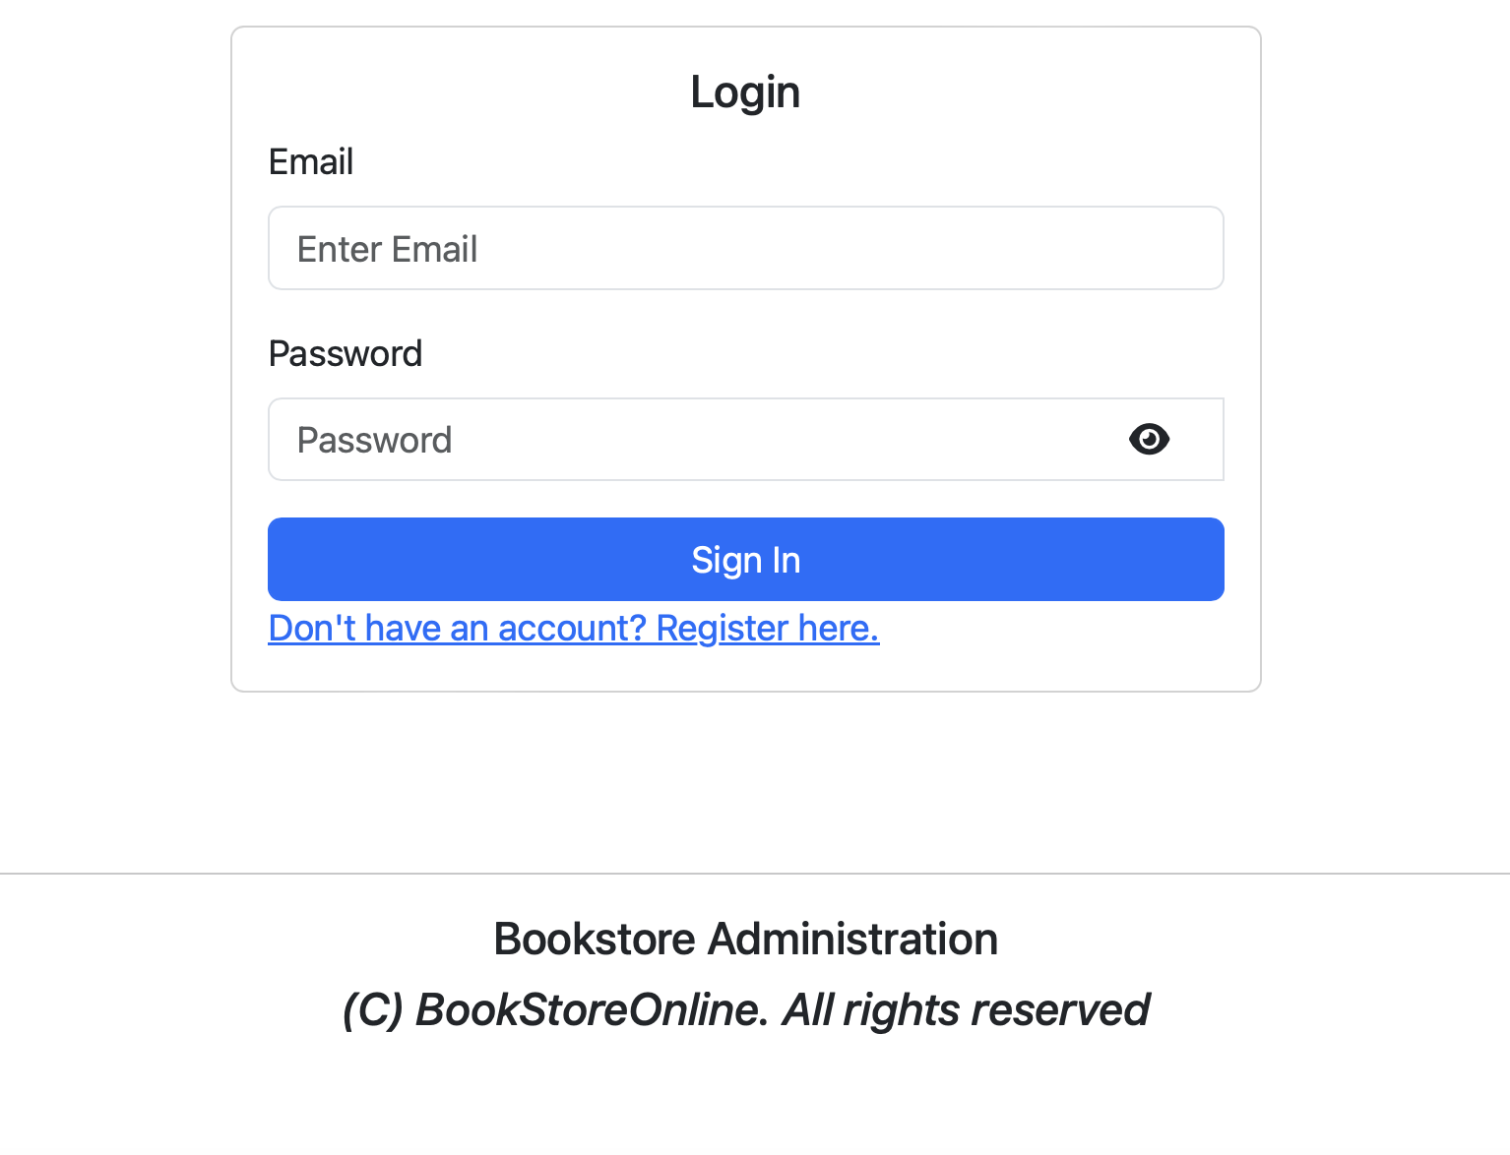

2: Customer selects “Register” and inputs all account info.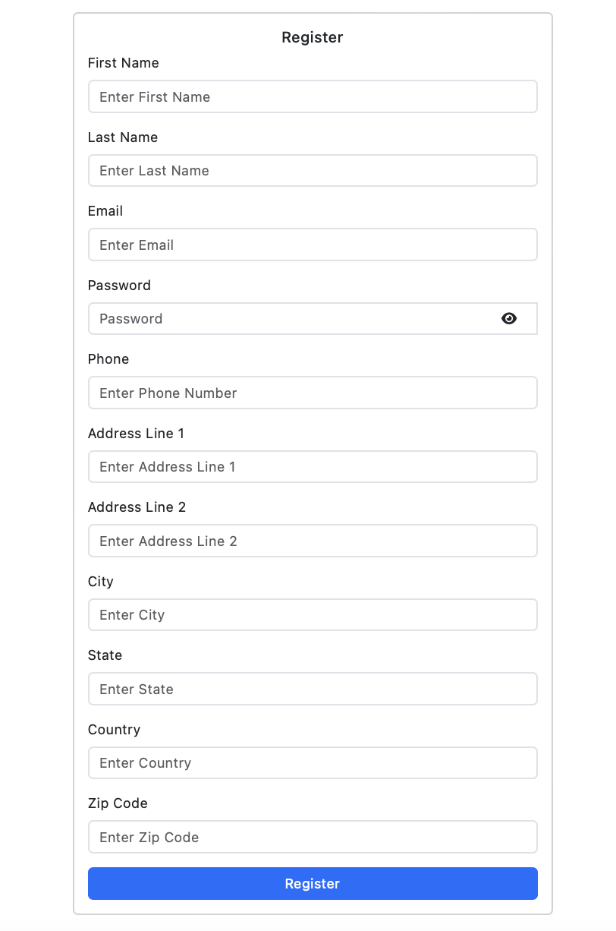

3: Customer logs in with email and password given previously.

Customer 2: Edit profile use case:

1: Customer logs in and is routed to the index page.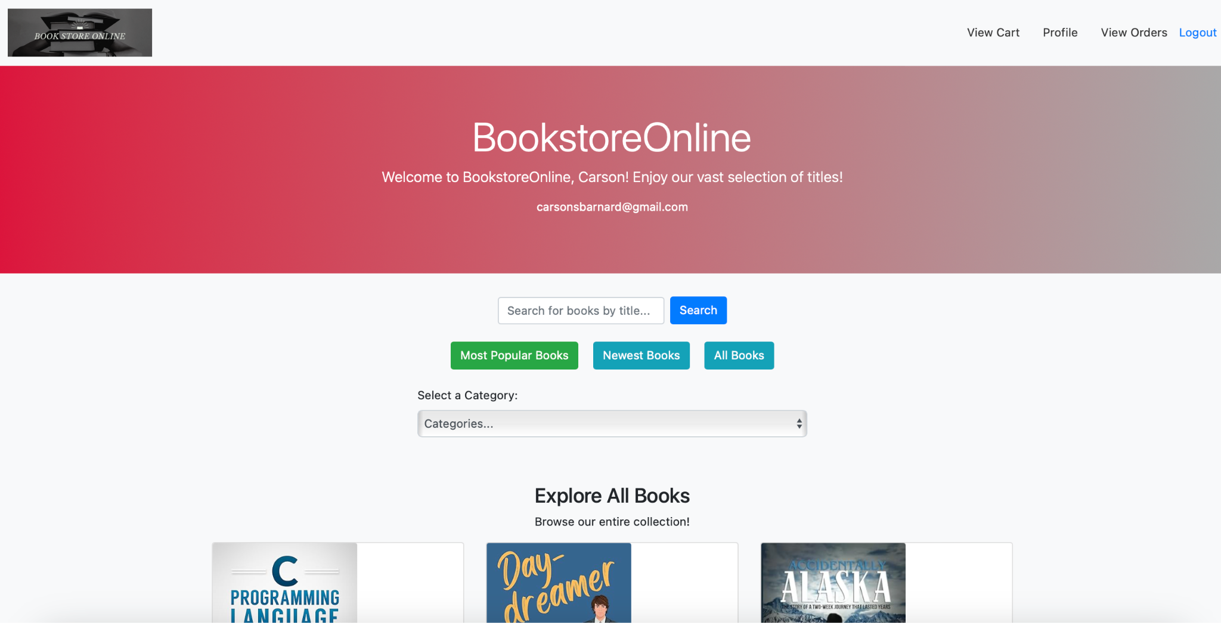

2: Customer selects the “Profile” button, and is directed to a view displaying their profile information.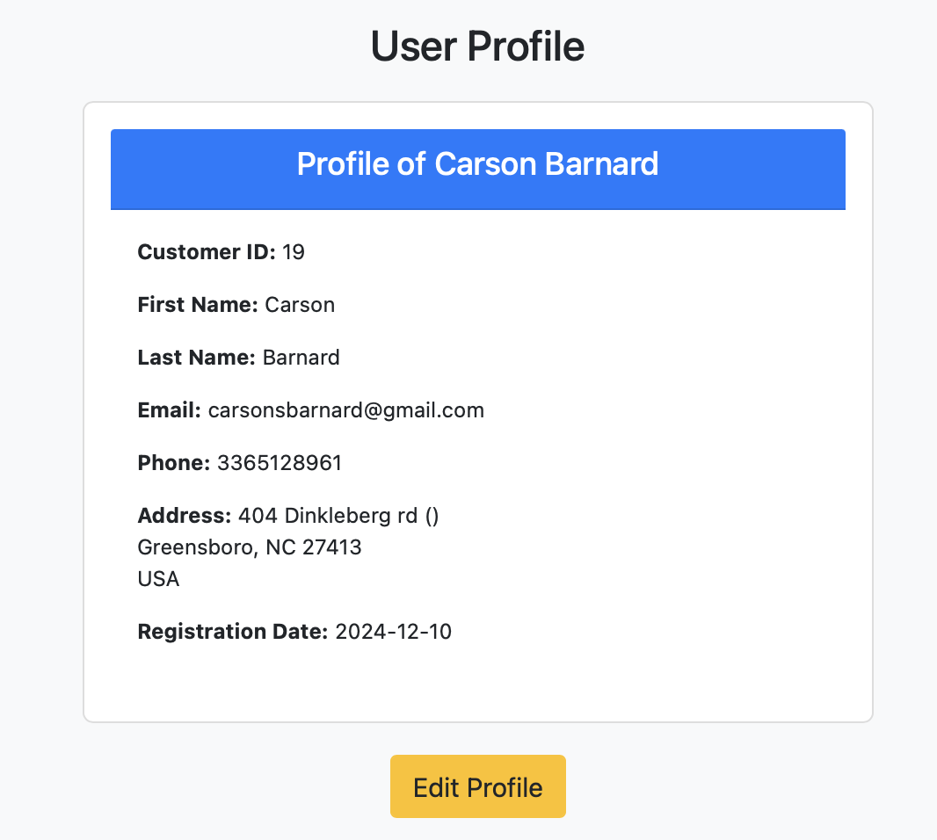

3: Customer selects “Edit Profile”.

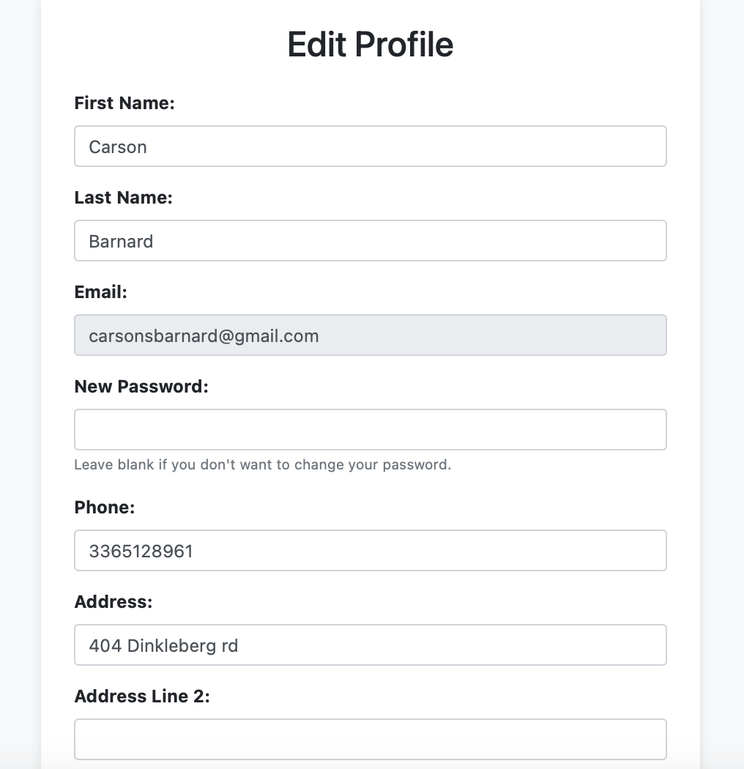

4: Customers fill out any details they would like to change.

5: Customer selects “Save Changes”, and information is updated.

Customer 3: Viewing books/reviews use case:

1: Customer logs in and is routed to the index page, listing all books.



2: Customer selects Most Popular on index page, listing most popular books.

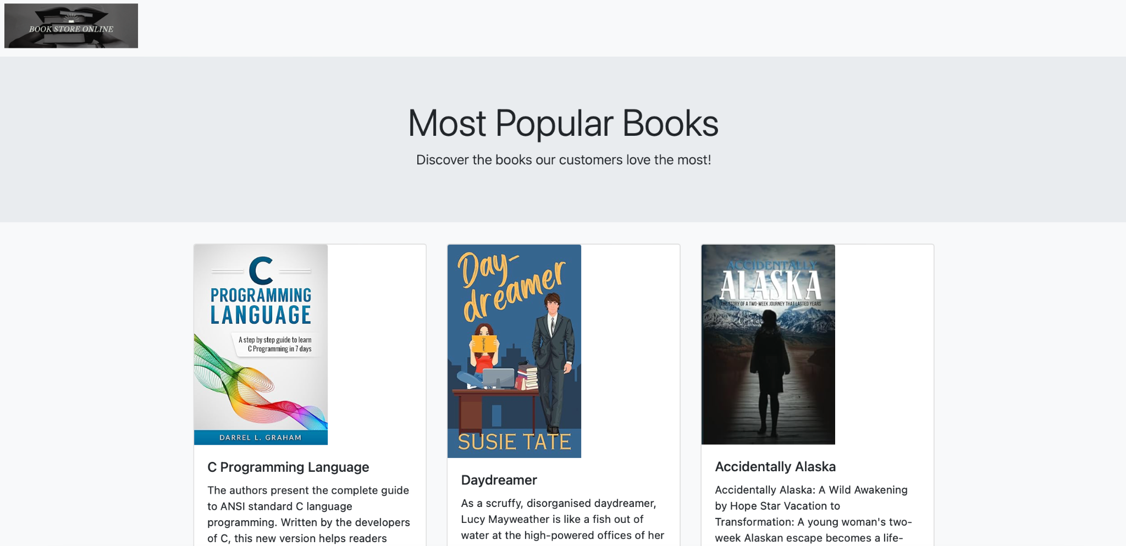

3: Customer selects Newest Books, listing books in newest to oldest.

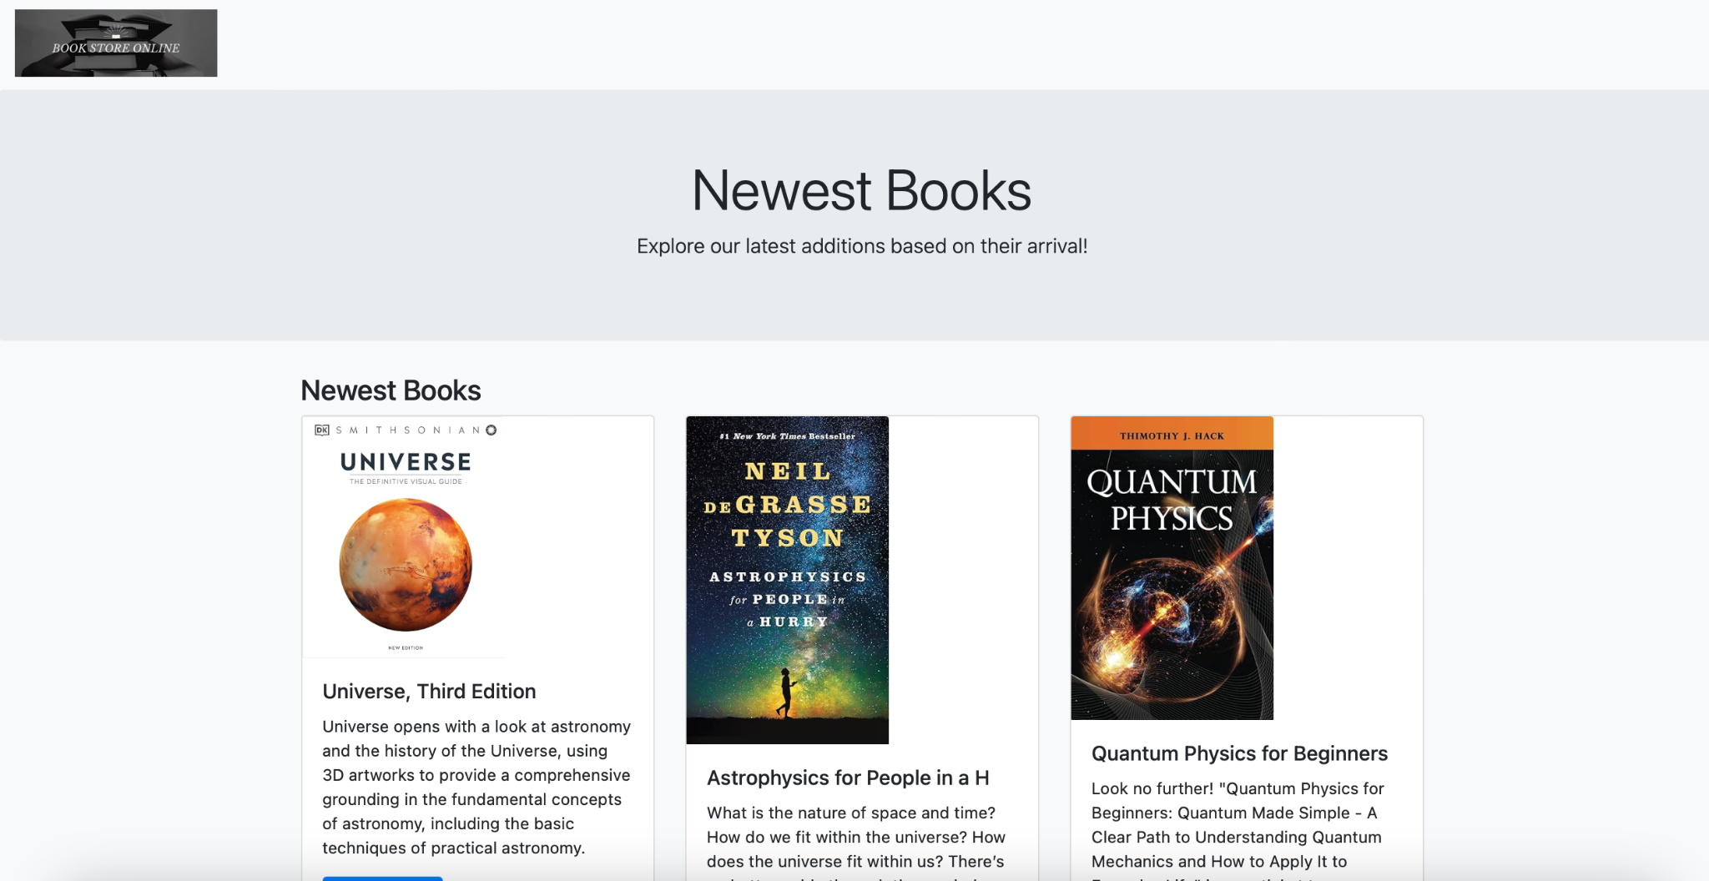

4: Customer selects a category of book on the drop down menu.

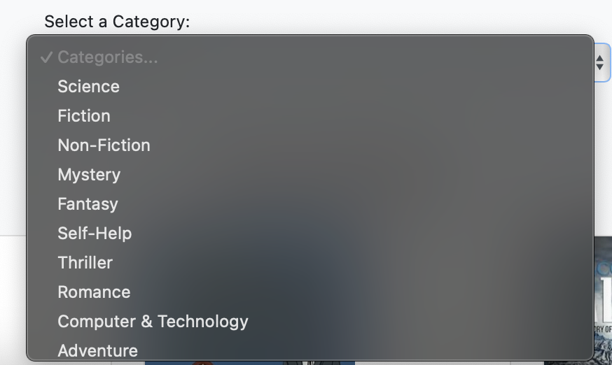

5: Customers search for their desired book using part of its name.

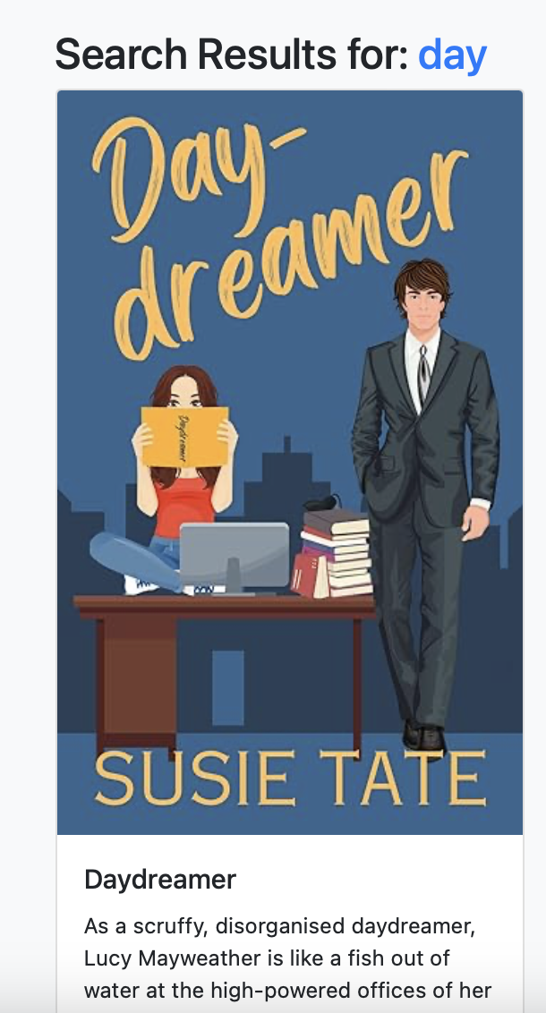

6: Customer selects “View Details”, and sees all relevant information and reviews for certain books.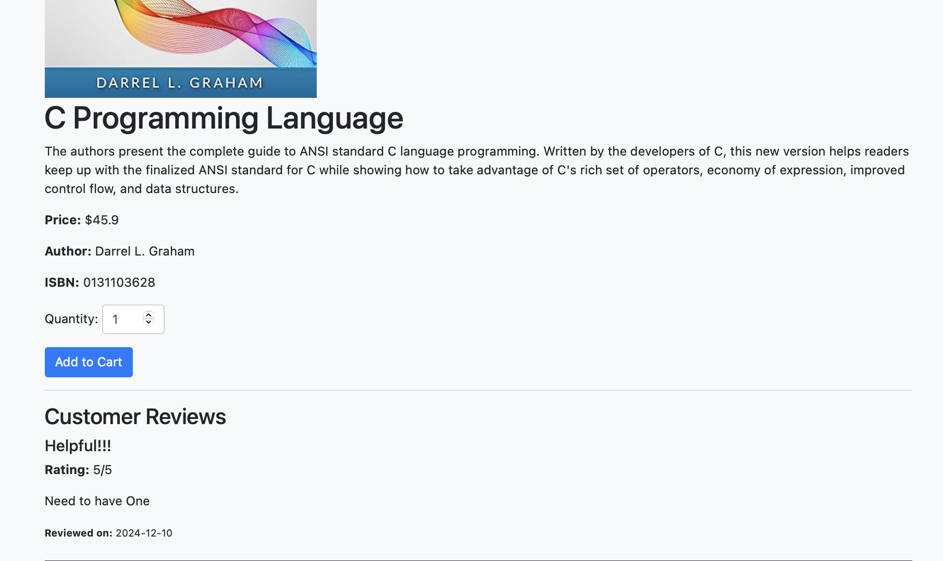

Customer 4: Ordering a book use cases:

1: Customer logs in and finds a book however they choose to (as listed before).

2: Customer adds directly to cart from view OR views the books individual detail page with reviews, and adds to cart from there- Choosing the quantity.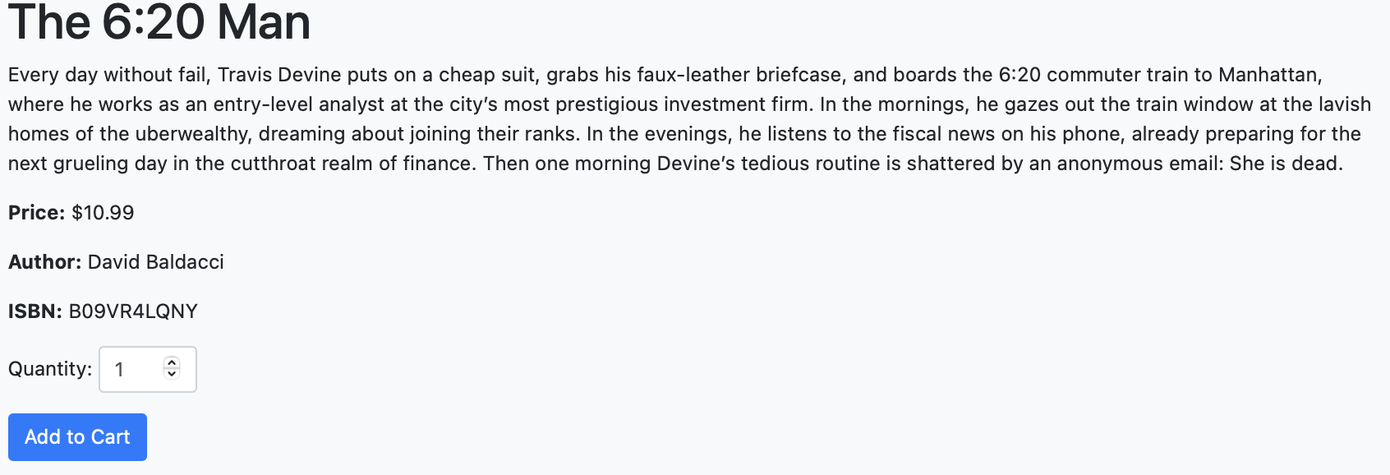

3: Customers are routed to the cart page to then manage their order, ensuring everything is correct. Customers also have the ability to edit the quantity of purchases and remove purchases from the cart.

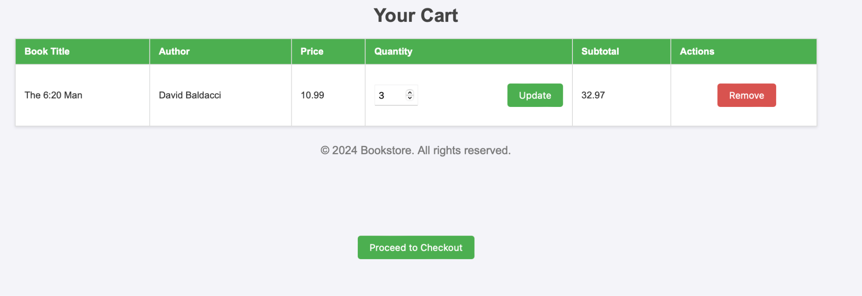

4: Customer hits checkout, and order is confirmed.

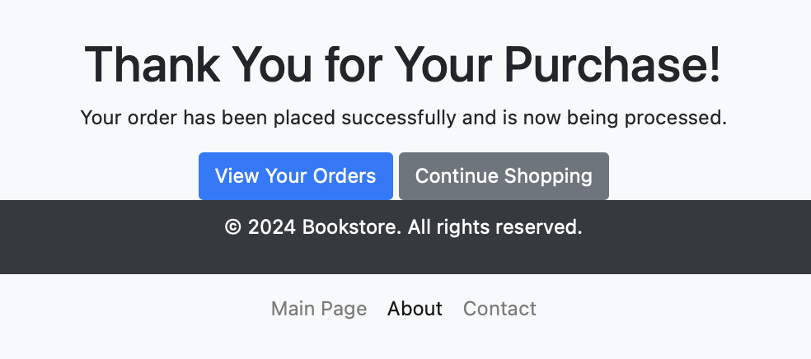

Customer 5: Reviewing a book use cases:

1: Customers go to their “My Orders” page, accessible from the index and most pages on the website.

2: Customer goes to the order/book of which they would like to review.

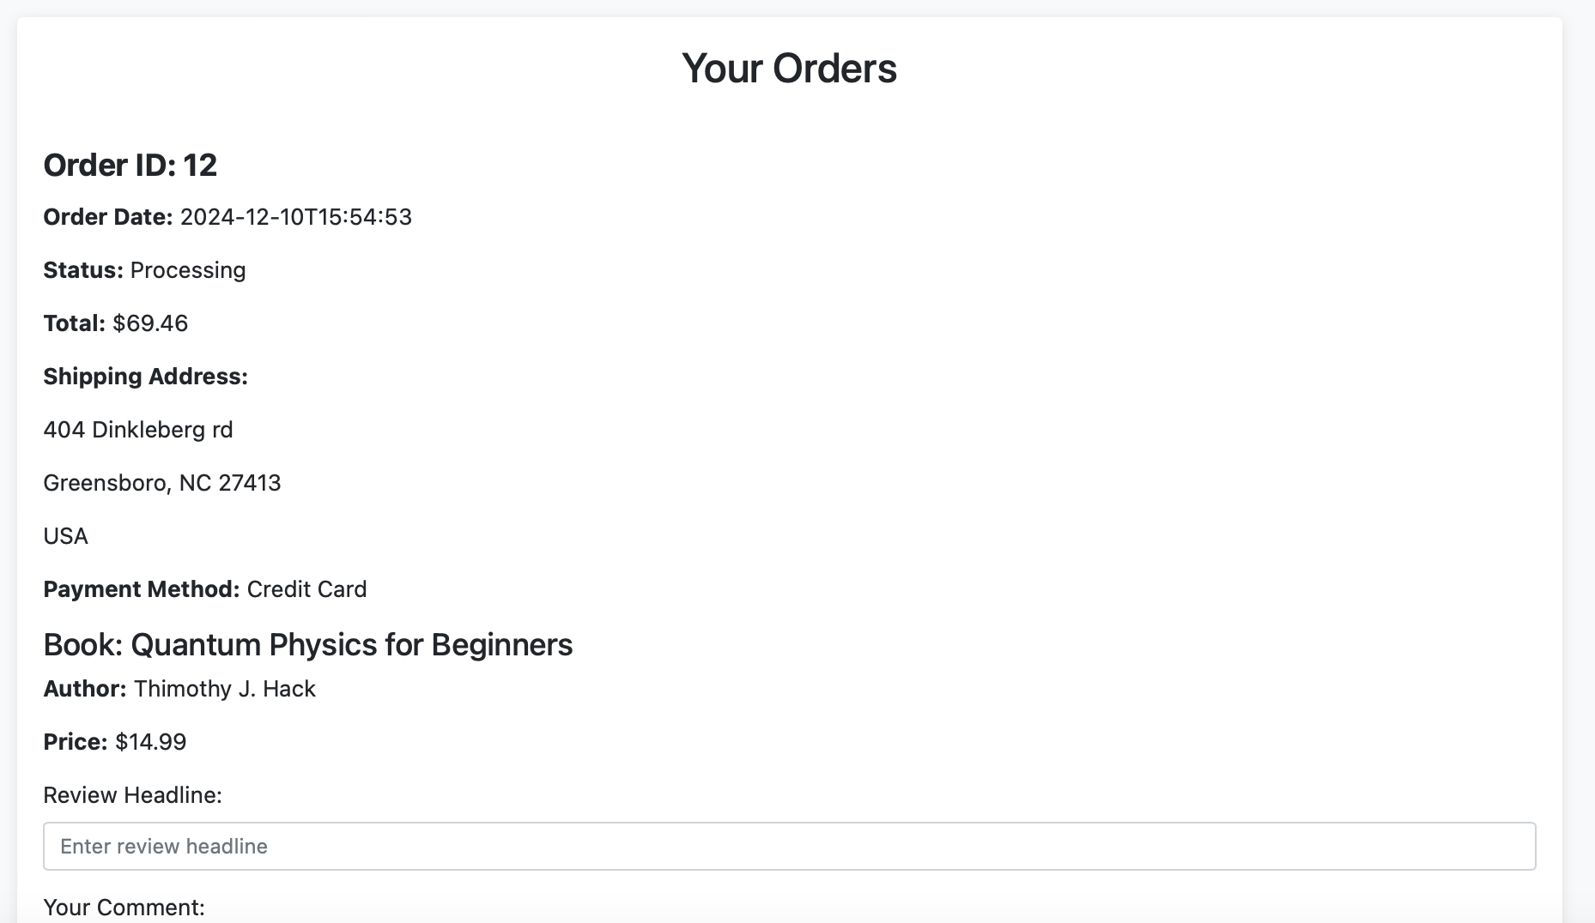

3: Customer enters headline, review description, and a rating for the book they are reviewing.

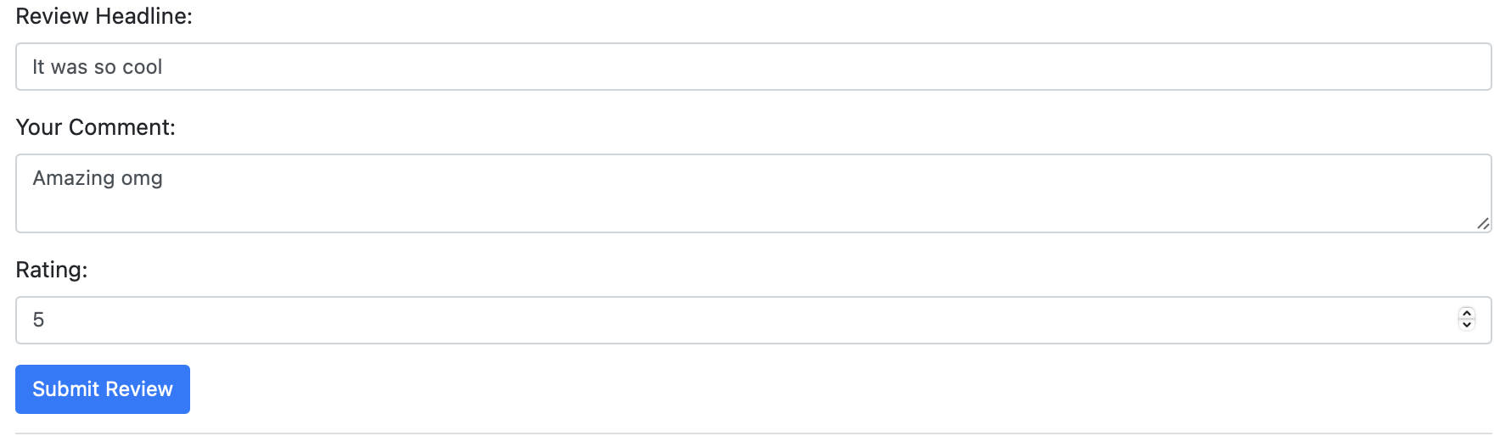

4: Customer presses submit, and the review is posted (Success message is given).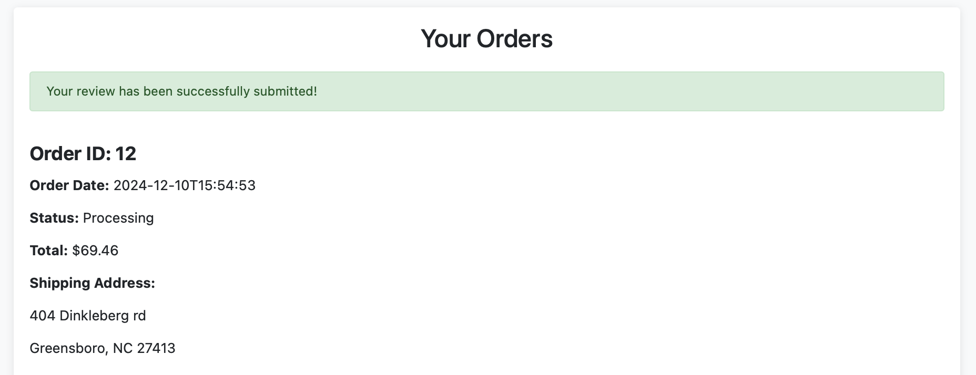

SysAdmin: View Customer Statistics, & Modify Profile use cases

1. Provider P1 views customer statistics. P1 modifies his profile. P1 exits.

SysAdmin: View Usage statistics, View/delete Reviews, Manage User use cases

1. Admin logs in and enters queries for several different statistics; for example, current number of customers, current number of providers.

2. Admin views all reviews, sees C5’s inappropriate reviews, deletes them, bans C5.

3. Admin logs in again and checks that C5’s review is deleted.

4. C5 tries to login but can no longer log in.